Irish Festival Parade
March 16, 2019
At 12:00 pm
Line up begins 10am
Clare VFW
145 Wilcox Parkway
Clare, MI 48617
General Information
- Register by March 11th
- Entry Fee $25
- Not required but suggested is a donation of non-perishable food items to the Kathy Rynearson Memorial Food Drive held at Witbeck’s Family Foods
- Irish themed entries are appreciated
- Limit of two (2) entries per business, non-profit, group or family
- Parade line up signs will be posted along Schoolcrest, please follow these signs
- Children under 5 must be accompanied by a parent and are not allowed to operate machinery or livestock
- All animal entries must provide a ‘pooper scooper’
- Please, do not toss candy from floats or vehicles! However, you may distribute candy while walking along the parade route
- One winner will be chosen by the Grand Marshall for Best Entry
In consideration of the acceptance of our entry in the Irish Festival Parade, we hereby release the sponsoring group connected with said parade from any and all liability for any and all injuries or damages whatsoever arising from our participation in the aforementioned parade. Signature on application is responsible for making sure all persons in entry know and understand parade rules.
Contact Name:
Phone:
Business/Non-Profit/Group/Family Name:
Will your entry be playing music, using a PA system or using horns: Yes or No
Address:
Email:

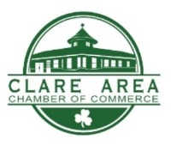
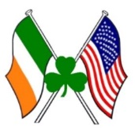
Please return this form to:
Clare Area Chamber of Commerce
201 West 4th Street
Clare, MI 48617
Or Email manager@claremichigan.com
For questions, please call the Clare Area Chamber office 989.386.2442

